# 

Contents

Topic: Working with Excel 2

Basic Usage 2

1. Class Example 2

a. Scenario 2

b. Data Set 2

c. Example 2

2. Video 3

Topic Multiple files with Excel 3

Basic Usage- 3

1. Class Example- 3

a. Scenario 3

b. Data Set 3

c. Example 3

2. Video 3

Topic: Excel and Power BI 4

Basic Usage 4

1. Class Example 4

a. Scenario 4

b. Data Set 4

c. Class Example 5

Class Question-

Open PowerBI Desktop and Import data from the view Sales.vSalesPerson found in AdventureWorks.

* Create a Slicer with the Column JobTitle and by clicking on the Slicer Visual
* The Slicer should not have North American Sales Manager as seen below.
* Two slicers may be used but only one slicer can be visible

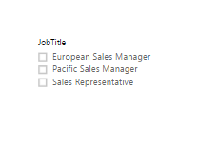

Topic: Working with Excel – As well as using the Power BI Desktop to connect to data and build reports and visualizations, you can also just use simple data like something you might store in Excel. People have Excel files all over the place, you know businesses, they’re often, very often run from Excel and we see that as a really first class source of content for Power BI as well.

Basic Usage – The simplest way of using Excel with the Power BI service is just to take a standard Excel spreadsheet and upload it into Power BI and start using the data.

1. Class Example – Often the business has multiple sources of data. The task set up for next week is to get with your team member who has been creating reports in excel.
   1. Scenario – Some of your colleagues are using Excel as their primary reporting tool. You want to collaborate with them and use their Excel files using Power BI desktop.
   2. Data Set – Excel file CarSales_Data.xlsx

OneDrive Link <https://1drv.ms/x/s!AgsRLppxitDjgV0fzDD8PqgqVh2D>

* 1. Example – Open Power BI desktop/Get Data/ and choose Excel as a source. With the navigator widow you can preview if there is any cleaning that needs to be done with the data. **Click on Edit to make changes, instead of NULL we need to put No Value Listed in the Address1 column**. Close and Apply

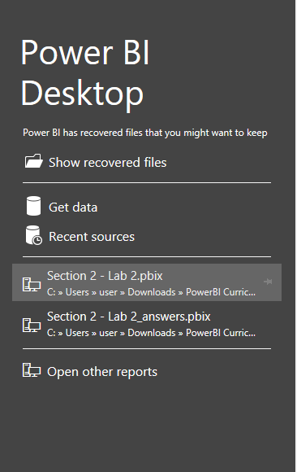 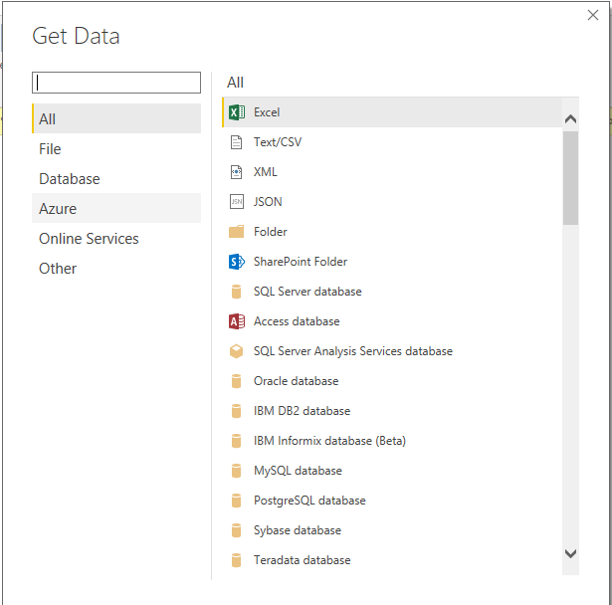 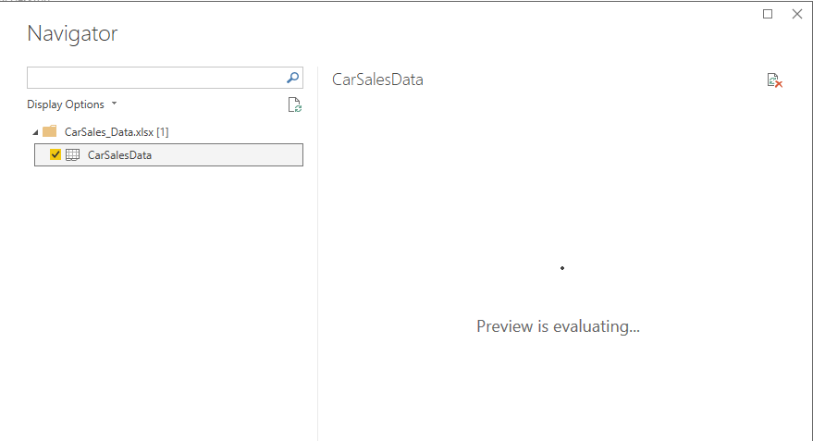

# Topic Multiple files with Excel

Basic Usage- There will be times when there is a need to load several excel files at the same time

1. Class Example- Some of your colleagues are using Excel as their primary reporting tool. You want to collaborate with them and use their Excel files using Power BI desktop.
   1. Scenario - Some of your colleagues are using Excel as their primary reporting tool. You want to collaborate with them and use their Excel files using Power BI desktop.
   2. Data Set – CarSales_Geography.xlsx

OneDriveLink <https://1drv.ms/f/s!AgsRLppxitDjgV-ZutM0bPAq1UjD>

* 1. Example – Open Power BI desktop/Get Data/ and choose Excel as a source. With the navigator widow you can preview if there is any cleaning that needs to be done with the data. Notice that both pages are available to select. Choose both and Click on Edit to make changes. **The Invoice tab in the Sales table needs to have a Date datatype. Also filter the Reporting year to only 2014 and 2015**.

  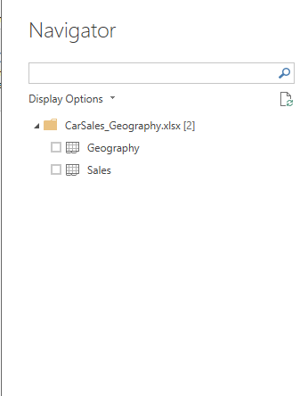

Topic: Excel and Power BI – Power BI works well with Excel. Later in this course we will take charts and graphs created in Excel and upload them into PowerBI. First, however we need to get familiar with Excel. Here we will do a brief introduction into Pivot Tables and Charts

Basic Usage –

1. Class Example – Our goal is to create a small dashboard illustrating the number of employees being hired for the past few years by department as seen below

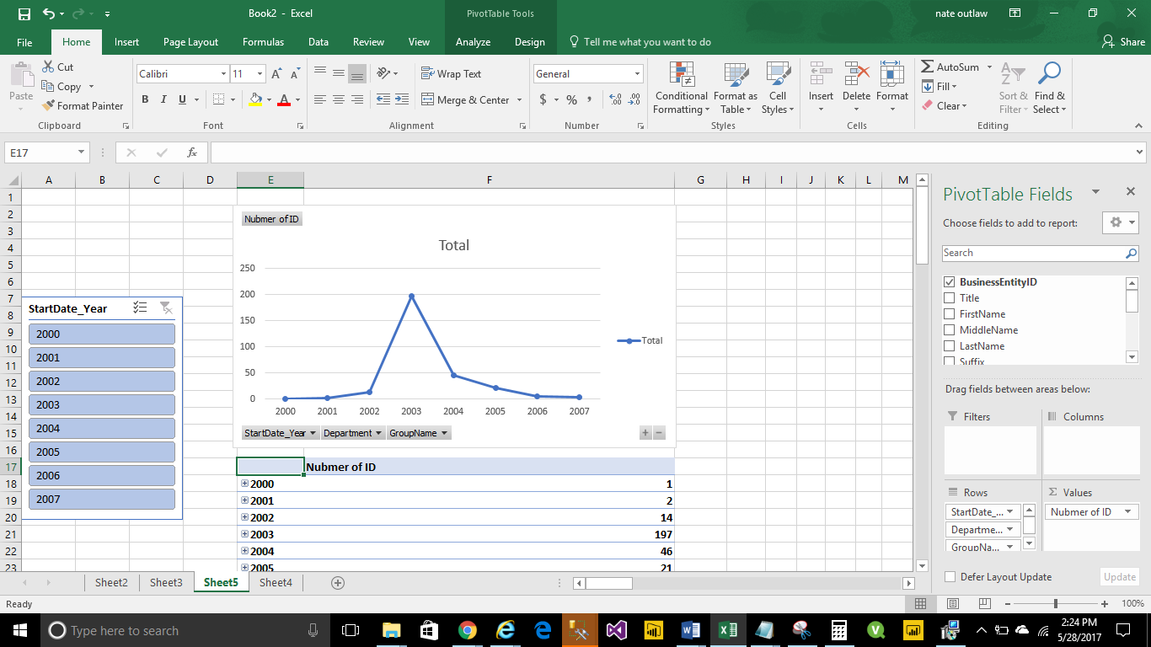

* 1. Scenario – A former developer has created a view with information about the number of employees being hired at the company
  2. Data Set – <https://1drv.ms/u/s!AgsRLppxitDjgWCfb4_TrHgnnVHv>

Create a table from the [HumanResources].[vEmployeeDepartment] found in AdventureWorks and rename it Employee_Department_Modified. Create additional columns; StartDate_Year, StartDate_Quarter and StartDate_Month in Sql

* 1. Class Example

In Excel go to the Data Ribbon and choose Sql Server. Enter your ServerName and DB.

Select the proper table followed by a PivotTable. Next we need to enter a couple of values and colums.

Insert BusinessEntityID into the values section, make sure this is a Count and not a Sum of the value.

Next we will add as a Row value StartDate_Year, Department, and GroupName. Modify the chart to a Line Graph and add a Slicer to parameterize the StartDate_Year.

